Ex No : 7 Practice with ExpressJS
Date : 16/09/25

Aim
To practice the backend development framework ExpressJS
Procedure :

1. Install Node.js and Set Up the Environment
- Download and install Node.js.
- Check installation:
- node -v
- npm -v

2. Initialize a New Express Project
- Create a new project folder and navigate into it:
- mkdir my-express-app
- cd my-express-app
- Initialize npm:
- npm init -y
- npm install express body-parser

Code:
Code:
1.
const express = require("express");
const app = express();
app.get("/", (req, res) => {
res.send("Hello World from Express!");
});
app.listen(3000, () => {
console.log("Server running on http://localhost:3000");
});

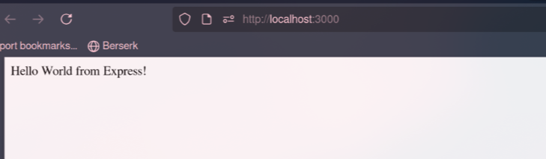
2.
const express = require("express");
const bodyParser = require("body-parser");
const app = express();
app.use(bodyParser.json());
const users = [{ username: "sethu, password: "12345" }];
app.get("/", (req, res) => {res.send("Welcome to the Login App ");
});
app.post("/login", (req, res) => {
const { username, password } = req.body;
const user = users.find(u => u.username === username && u.password === password);
if (user) {
res.json({ message: "Login successful!" });
} else {
res.status(401).json({ message: " Invalid credentials" });
}
});
app.listen(3000, () => console.log("Login app running on http://localhost:3000"));
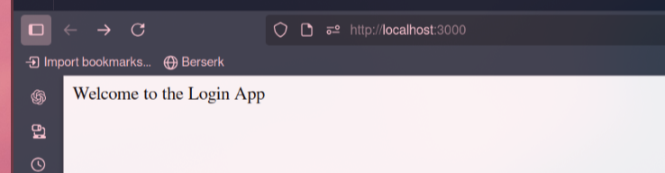

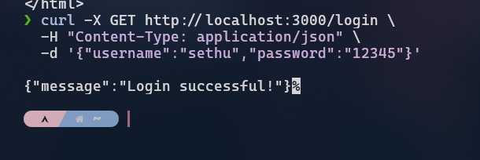
3.
const express = require("express");
const bodyParser = require("body-parser");
const { renderSlot } = require("vue");
const app = express();
app.use(bodyParser.json());
let todos = [];
app.get("/",(req,res) =>{
res.send("To do List");
});
app.post("/todos", (req, res) => {
const { task } = req.body;
todos.push(task);
res.json({ message: "Task added!", todos });
});
app.get("/todos", (req, res) => {
res.json(todos);

});
app.listen(3000, () => console.log("Todo app running on http://localhost:3000"));
S
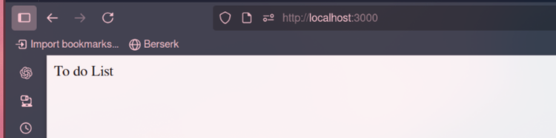
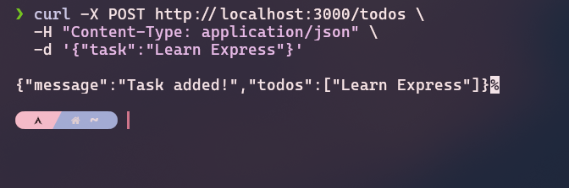

Result:
Thus , the implementation of ExpressJS was successful.

